The Islamia University of Bahawalpur
Department of Information Technology



SOFTWARE REQUIREMENTS SPECIFICATION
for
School mAnagement system

Student Name
Alisha Riaz
Session: Spring 2023 -2027

Supervisor
Omer Riaz
Bachelor of Science in Information Technology
Abstract

E-School (SMS) is a web enabled application developed in PHP and powerful MYSQL database backend. To implement E-School, schools do not require expensive hardware and software, all schools need is internet connection and desktops. Our system works as a centralized database and application that schools can easily access the system from anywhere based on the login credentials.
E-School is a platform independent system that virtually any user can access from anywhere through a standard internet accessible system. We can also customize E-School for individual school needs.
Administrators: School Management System helps administrators get the most accurate information to make more effective decisions. Teachers and administrators gain time saving administrative tools, parents gain immediate access to their children’s attendance and students can track their own progress. School Management System equipped features makes it possible to generate schedules and reports in minutes and to retrieve attendance records, teacher record, class schedule in just a few clicks.
Teachers: School Management Systems helps Teachers to complete daily attendance, track students attendance, input class schedule and detailed reports. Communicate with other staff members, students, and parents all via private message.
Students: School Management Systems helps Students to View attendance records and progress reports all online. Students also can communicate through private message and with teachers and admin’s online.

List of Figures
Figure 1 : Prototype Model Process. ......................................................................................................15
Figure 2 : Prototype Model Phases............................................................................................................17
Figure 3: Admin Rules................................................................................................................................21 Figure 4: Student Rules..............................................................................................................................22 Figure 5 : Teacher Rules ............................................................................................................................23
Figure 6 : Parent Rules ..............................................................................................................................24
Figure 7: Admin use case Diagram.............................................................................................................26 Figure 8: Student use case Diagram...........................................................................................................27 Figure 9 : Teacher use case Diagram..........................................................................................................27
Figure 10: Parent use case Diagram...........................................................................................................28

List of Abbreviations and Glossaries

SSI’s: | Server Side Includes
HTML: | Hyper Text Markup Language
PHP: | Hypertext Preprocessor
SQL: | Structured Query Language
SDLC: | Software Development Life Cycle
SMS: | School Management System

Table of Contents
Abstract..........................................................................................................................................2
List of Figures................................................................................................................................. 3
List of Abbreviations and Glossaries...............................................................................................3

Chapter 1
INTRODUCTION .............................................................................................................................6 Background....................................................................................................................................7
Problem Statement........................................................................................................................8 Objectives ......................................................................................................................................8 Importance of the Project..............................................................................................................9
Scope and Limitation of the Project..............................................................................................9

Chapter 2
LITERATURE REVIEW..................................................................................................................... 10 Introduction...................................................................................................................................11
E-School, School Management System Strategy........................................................................... 11
E-School for Management ............................................................................................................ 11
E-School for Teacher...................................................................................................................... 11
E-School for Student.......................................................................................................................12
E-School for Parent.........................................................................................................................12 Technologies used on E-School ......................................................................................................12

Chapter 3
METHODOLOGY ................................................................................................... ………………………14 Introduction....................................................................................................................................15 Methodology...................................................................................................................................15 Prototype Model.............................................................................................................................16
Advantages of Prototyping.............................................................................................................16
The Process of Prototyping ............................................................................................................16
Reason of using Prototype Model.................................................................................................. 16
Phases in prototype Model.............................................................................................................17

Chapter 4
Requirement Analysis.....................................................................................................................18 Introduction....................................................................................................................................19
System description ....................................................................................................................…..19
User description..............................................................................................................................20 Admin..............................................................................................................................................21
Student ...........................................................................................................................................22 Teacher...........................................................................................................................................23
Parent ...........................................................................................................................................24
System Requirement......................................................................................................................24
Functional Requirement................................................................................................................25
4.4.1.1 Admin.................................................................................................................................25
4.4.1.2 Teacher...............................................................................................................................25
4.4.1.3 Student ..............................................................................................................................25
4.4.1.4 Parent ................................................................................................................................25 4.4.2Non-Functional Requirement.................................................................................................26
4.4.2.1 Security ..............................................................................................................................26
4.4.2.2 Performance ......................................................................................................................26
4.4.2.3 Availability...........................................................................................................................26
4.4.2.4 User Friendly .......................................................................................................................26
4.5 System Analysis..........................................................................................................................26
Use case Diagram ............................................................................................................................26
1. Admin ..........................................................................................................................................26
2. Student ........................................................................................................................................27
3. Teacher........................................................................................................................................27
4. Parent ..........................................................................................................................................27
Chapter 5
Conclusion and Future Work .................................................................................. …………………….29
Conclusion ......................................................................................................................................30
Future Work ...................................................................................................................................30

Chapter 1
INTRODUCTION

  - Background
When you ask the school to enter the electronic world in which he asked to electronic advantages make you processions electronic era which has become all the world is in it and that makes you continuously with students and teachers quickly Here you require a Website so that this site covers the needs of teachers and students at one time so that it is Students special site where watching the monthly marks obtained at the school and also can request permission in the case not to go to school and that teacher who can put signs and writes reports on each student activity, duties and violin can be to the director of the school that is watching all the students and teachers in terms of absence and attendance and also can see that all the observations and monitors all complaints and reports and so in a short time and quickly. Hence we can say that this site facilitates all administrative tasks within and outside the school with ease. Web pages will often require more screen space than is available for a particular display resolution. Most modern browsers will place a scrollbar (a sliding tool at the side of the screen that allows the user to move the page up or down, or side-to-side) in the window to allow the user to see all content. Scrolling horizontally is less prevalent than vertical scrolling, not only because such pages often do not print properly, but because it inconveniences the user more so than vertical scrolling would (because lines are horizontal; scrolling back and forth for every line is much more inconvenient than scrolling after reading a whole screen; also most computer keyboards have page up and down keys, and many computer mice have vertical scroll wheels, but the horizontal scrolling equivalents are rare). When web pages are stored in a common directory of a web server, they become a website.
A website will typically contain a group of web pages that are linked together, or have some other coherent method of navigation. The most important web page to have on a website is the index page. Depending on the web server settings, this index page can have many different names, but the most common is index.html. When a browser visits the homepage for a website, or any URL pointing to a directory rather than a specific file, the web server will serve the index page to the requesting browser. If no index page is defined in the configuration, or no such file exists on the server, either an error or directory listing will be served to the browser. A web page can either be a single HTML file, or made up of several HTML files using frames or Server Side Includes (SSIs).
Frames have been known to cause problems with web accessibility, copyright, navigation, printing and search engine rankings, and are now less often used than they were in the 1990s. Both frames and SSIs allow certain content which appears on many pages, such as page navigation or page headers, to be repeated without duplicating the HTML in many files. Frames and the W3C recommended alternative of 2000, the <object> tag, also allow some content to remain in one place while other content can be scrolled using conventional scrollbars. Modern CSS and JavaScript client-side techniques can also achieve all of these goals and more. When creating a web page, it is important to ensure it conforms to the World Wide Web Consortium (W3C) standards for HTML, CSS and other standards. The W3C standards are in place to ensure all browsers which conform to their standards can display identical content without any special consideration for proprietary rendering techniques. A properly coded web page is going to be accessible to many different browsers old and new alike, display resolutions, as well as those users with audio or visual impairments. Usually, Web pages today have become more dynamic. Web pages are dynamic, which is generated from the server-side when asked to do so, and then serve the end user. These types of web pages usually do not have a fixed link, or a fixed address, associated. Today, it can be seen in many popular forums, and online shopping, even on Wikipedia. This practice is designed to reduce the amount of static pages instead of storage with associated information in the database pages. Some search engines may have difficulty in indexing web pages and dynamic web pages, so it can offer static pages in those cases.

  - Problem Statement
The problem currently facing many schools is the management of courses. Here, the teacher does not properly handle their workload, and sometimes the courses are not offered on time. The number of students who must study the course is not followed. The main problem is to managing the teachers work and courses scheduling. Also, in the school the student cannot know the marks that the student get it on the exam, but when the student goes to school and also, the teacher cannot be assured that the student has a sign seen by the parent and guardian also cannot, to know his son's performance in school, but he must go to school and ask for it.

  - Objectives
Main Objective: - Build a web site that support mobile working to manage the different school activities.
Sub Objective:

- Track student schedules.
- Hold records of the student's attendance.
- Enrolling new students.
- Help parents to follow up to his son's performance in school.
- Help the teacher to facilitate access to parents and introduce them to the extent of deficiencies at the student process

  - Importance of the Project
The school as institution to provide students, children and young person's to science and education, and is a building where students learn reading, writing, mathematics, science and various other studies, what are the features of the school and its goals and where are the various teaching centers? What are the facilities and equipment that requires availability in the school We must therefore provide students with the electronic knowledge, because the world is with electronic features and became dependent on technology dramatically and through the presence of the Web site of the school makes it easier for students to deal with websites and opens a large field of learning and enter this world full of information and useful things that make it benefit significantly and it also helps to understand the field of development through research and discovery of new information in the materials that can also cultures through the discovery of new methods of learning and teaching methods In Pakistan, the student must have a knowledge of technology and science, which has become the easy way to reach the outside world in order to raise the educational level of the student and also to send a message to all the world that the Palestinian student can keep up with the electronic world quickly despite the wars that are exposed and that he could be scientifically advanced in the world.

  - Scope and Limitation of the Project
The Website Design School, to provide an easy way to get the student information. On the website was chosen PHP programming language in order to be available to him from the ease and durability in this language. This project is based on any operating system where the programming language is open source which helps to make changes to what it is compatible with any school.
This project will be applicable in every country of this world, then it will involve all schools. We will make the testing process in many Schools.

Chapter 2
LITERATURE REVIEW

2.1 Introduction
This chapter review and identify concepts and related work about E-School.

2.2 E-School, School Management System Strategy
E-School is a complete school information management solution. Today's schools need to manage more information than ever before. Without a solid internal infrastructure for teachers, administrators and Parent’s to share data, critical school and student information can be lost, or worse leading to a host of problems that can effect of a school's image and endurance. To remain competitive, school needs a simple solution that can run individual function, connect their entire operation, use the web as a key communication tool and simplify day to day operational responsibilities, giving staff more time with students.
E-School automates various scheduling activities of school and optimizes the use of premium resources. Concerned authorities can now easily and seamlessly use the system to create timetables, otherwise a time consuming and tedious task.

    - E-School for Management

- Single points school management software.
- Enable internet front-end for the school.
- Connect with Parents effectively
- Build and Manage community of parents, teachers and students
- Manages all administrative records with zero redundancy
- Achieve best possible resource optimization
- Automate all operational functions like Attendance, Exam scheduling and class scheduling.
- Automatic generation and regeneration of information with dynamic substitute management.
2.2.2 E-School for Teacher

- Complete attendance automation.
- Interact with parents efficiently and effectively.
- View analytical reports
- Private and Internal messaging system.
- View own attendance.
- View Student Record.
- View parent’s record.
- View Class that has been assigned to him/her.
- View Noticeboard of School online.

2.2.3 E-School for Student

- Real time exposure for better learning.
- Interaction with other admin’s, teachers and parents.
- View own attendance.
- View Class schedule in advance.
- View current events and holidays at school.

2.2.4 E-School for Parent

- Get latest updates about school through Noticeboard.
- Share knowledge and views with admin’s and school through various features like private messaging.
- Get connected with schools effectively and easily
- Interact with teachers through private messaging system.
- know status about her/his child through attendance etc.

2.3Technologies used on E-School

HTML: is the standard markup language used to create web pages. Web browsers can read HTML files and render them into visible or audible web pages. HTML elements form the building blocks of all websites. HTML allows images and objects to be embedded and can be used to create interactive forms. It provides a means to create structured documents by denoting structural semantics for text such as headings, paragraphs, lists, links, quotes and other items.

CSS: is a Web page derived from multiple sources with a defined order of precedence where the definitions of any style element conflict. The Cascading Style Sheet, level 1 recommendation from the World Wide Web Consortium (W3C), which is implemented in the latest versions of the Netscape and Microsoft Web browsers, specifies the possible style sheets or statements that may determine how a given element is presented in a Web page. And describes how HTML elements are to be displayed on screen, paper, or in other media.

PHP: is an open source server-side language which is used for creating dynamic web pages. It can be embedded into HTML. PHP is usually used in conjunction with a MySQL database on Linux/UNIX web servers. It is probably the most popular scripting language. And it is a widely-used general-purpose scripting language and interpreter that is freely available. A full explanation of all the PHP tags.
MySQL database: MySQL is the world's most popular open source database. With its proven performance, reliability and ease-of-use, MySQL has become the leading database choice for web-based applications, used by high profile web properties including Facebook, Twitter, YouTube, Yahoo! and many more.

Chapter 3
METHODOLOGY

3.1 Introduction

The third chapter states the methodology used to reach the objectives of the project. The framework in which software is designed, developed, and maintained is known as the Software Development Life Cycle (SDLC). It shows the steps, phases, milestones, and evolution of the software development process. There are many types of models used in software design and development. Among them are the spiral models, rapid development model, Evolutionary model, waterfall model, prototyping model, etc.

3.2 Methodology

Prototyping Model has been used to develop this application. The Prototyping model is a technique for quickly building a function but incomplete model of the information system. There are several kinds of prototypes but they all intend to reduce risk by building a quick and dirty replica or mockup of the intended system. It can be used to demonstrate technical feasibility when the technical risk is high. It can also be used to better understand and elicit user requirements. In either case, the goal is to reduce risk and limit costs by increasing understanding of proposed solutions before committing more resources, as shown in figure 1.

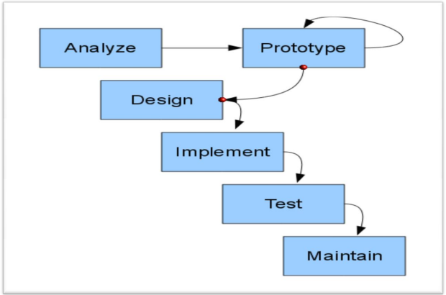

3.3 Prototype Model

3.3.1 Advantages of Prototyping

  - Reduces development time.
  - Reduces development costs.
  - Requires user involvement.
  - Developers receive quantifiable user feedback.
  - Facilitate system implementation since users know what to expect.
  - Results in higher user satisfaction.
  - Exposes developers to potential future system enhancements.

3.3.2 The Process of Prototyping
  - Identify basic requirement: Determine basic requirements including the input and output information desired. Details, such us security, can typically be ignored.
  - Develop initial prototype: The initial prototype is developed that includes only user interfaces.
  - Review: The customers, end-users, examine the prototype and provide feedback on additions or changes.
  - Revise and enhancing the prototype: Using the feedback, both the specifications and the prototype can be improved. This method involves a series of iterations and refinement until the prototype product is a fully working system, and the user is satisfied.
3.4 Reason of using Prototype Model
- Users are actively involved in the development.
- Since in this methodology a working model of the system is provided, the users get a better understanding of the system being developed.
- Since in this methodology a working model of the system is provided, the users get a better understanding of the system being developed.
- Since in this methodology a working model of the system is provided, the users get a better understanding of the system being developed.
- Errors can be detected much earlier.
- Quicker user feedback is available leading to better solutions.
- Missing functionality can be identified easily.
- Confusing or difficult functions can be identified Requirements validation, Quick.
- implementation of, incomplete, but functional, application.

3.5 Phases in prototype Model

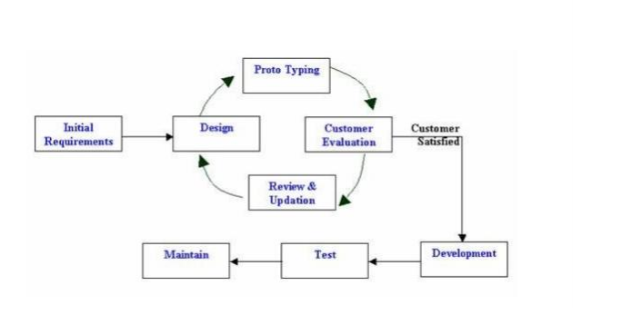
Phase 1: Identify some requirements to begin with: Get lists of some major requirements which define the need for the new system including the main input output information.

Phase 2: Develop initial prototype: Develop a basic initial prototype which only has UI screens.

Phase 3: Review the prototype: End users and SME’s work and examine the prototype and provide feedback for improvements/enhancements.

Phase 4: Revise and enhance the prototype: Scope is changed based on feedback from end users and the prototype is enhanced and refined to accommodate user feedback.

Chapter 4
Requirement Analysis

4.1 Introduction
This chapter will provide a full description of the system and its users. Then it depicts the functional and non-functional requirements that have been collected using several methods from brainstorming, interview and e-surveys. After determining the most important requirements, requirement analysis was adopted using several tools such as use-case diagram, sequence diagram and activity diagram.

4.2 System description E-school (SMS)
It is a system serving the student and the teacher and parents This electronically where it will be the work of a Web application, The idea of this system to enable the student to enter the site and get information that given by the school electronically and also keep pace with all that is happening again in the school in general It also operates a system for parents who can follow their children through this system in terms of teacher's supervisor's names on their students' attendance and monthly, as well as teacher observations own sons and students can also follow the administration of the website And also seeing the school quota schedule for the student as well as attendance rates and absenteeism from school, Where parents can see them for the student And also the daily absences for the school system, with the possibility of determining the cause of absences for each student, also for teachers and staff, And also can through the site to be communication between teachers and parents in order to follow the activities of the students inside the school.

4.3 User description

There are four main users for the proposed system; these are Admin, student, teacher and the parent. Each user can perform several different functions during the use of the system. These functions were determined according to the design of the proposed system and a user-friendly functions to make the system more effective and efficient. Figure 4-1 summarizes the functions performed by each user.

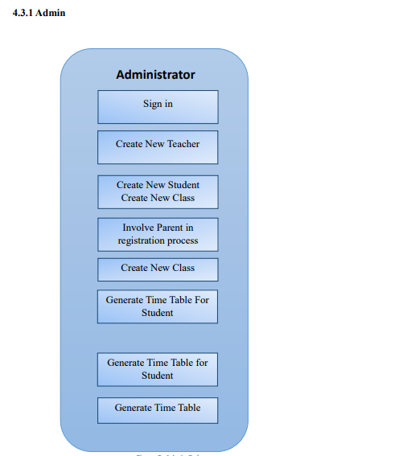

As shown, the admin can Create New Teacher and Create New Student and Involve Parent in registration process and Create New Class and Generate Time Table for Student and Generate Time Table for Teacher.

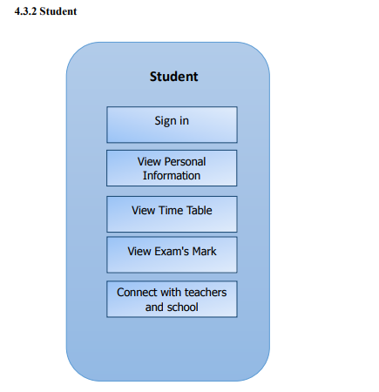
View Daily Attendance

As shown, the student can View Personal Information and View Time Table and View Daily Attendance and Connect with teachers and school management System.

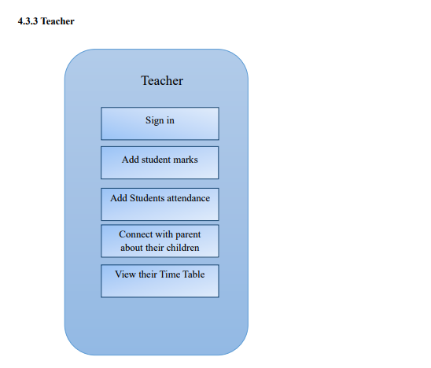
As shown, The Teacher can add student marks And Add Students attendance And Connect with parent about their children And View their Time Table.

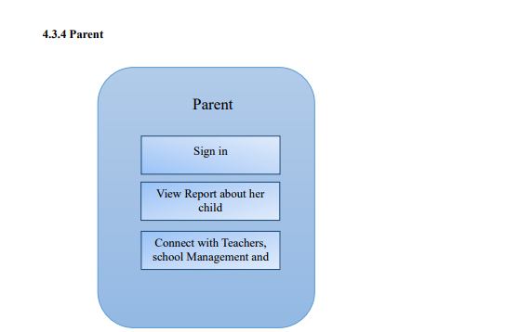
As Shown, The Parent can sign in And View Report about her child And Connect with Teachers, school Management and other parent.

4.4 System Requirement
Before creating any website or a mobile App, it is necessary to visualize the layout, design and all features intended to be incorporated. In addition, how users will interact with each page and icon and how the website/App should perform (behavior, load time etc.). Requirements are the necessary attributes in the system, a statement that identifies a capability, characteristic or quality factor of the system in order to have value and utility to the users. Once the requirements are set, developers can initiate the other technical work including system design, development, testing, implementation, and operation. For any system, there are functional and non-functional requirements to be considered while determining the requirements of the system. The functional requirements are user “visible” features that are typically initiated by stakeholders of the system, such as generate report, login, and signup. On the other hand, nonfunctional requirements are requirements that describe how the system will do what it is supposed to do, for example, security, reliability and maintainability.

4.4.1 Functional Requirement
4.4.1.1 Admin

  - Create, edit and delete student account.
  - Create, edit and delete teacher account.
  - Create, edit and delete parent account.
  - Publish news on noticeboard for users (Teacher, Student, and Parent).
  - Store, edit, delete, calculate and print student's information.
  - Add Classes and Subject to the teachers.
  - Change user information.
  - Search student's information per name and per ID.
  - Create, edit, delete and print class schedule/time table.
  - Change System settings.
  - Change their account's information.

4.4.1.2 Teacher
  - Create, edit and delete student account.
  - Add Student's attendance per Subject.
  - Connect with Admin’s, student and parent.
  - View news on noticeboard for users (Teacher, Student, and Parent).
  - Change their account's information.

4.4.1.3 Student

  - View their attendance.
  - Ask their teacher and the admin
  - View class and subjects and teachers of that subjects.
  - View news on noticeboard for users (Teacher, Student, and Parent).
  - Change their account's information.

4.4.1.4 Parent

  - View the attendance of their children.
  - View news on noticeboard for users (Teacher, Student, and Parent).
  - Change their account's information.

4.4.2 Non-Functional Requirement
4.4.2.1 Security
The system have accounts for its users and only authorized users can access the system with username and password. The passwords are encrypted using a PHP function sha1 ().

4.4.2.2 Performance Easy tracking of records and updating can be done.
4.4.2.3 Availability
The system are available to users anytime, anywhere, just need a PC and Internet Connection. Also the system work in multiple web browsers like (Chrome, Mozilla, Opera, and Internet Explorer).

4.4.2.4 User Friendly The system have a friendly user interface and the system very interactive.
4.5 System Analysis
This part contains the analysis of the functional and non-functional requirements using use-case diagrams, and use-cases details. In addition, the interactive behavior of the activities is analyzed using sequence diagrams and activity diagrams.
4.5.1 Use case Diagram
This part contains the analysis of the functional and non-functional requirements using use-case diagrams, and use-cases details.
- Admin
The Admin can do After Login process the following function as shown in figure7:
• Add Teacher include (Modify/Delete).
• Add Student include (Modify/Delete).
• Add Parent include (Modify/Delete).
• Add Class include (Modify/Delete).

- Student
The student can do After Login process the following function as shown in figure8:
• View Personal Information.
• View Timetable.
• View Courses schedule.
• View Personal Details.

- Teacher
The Teacher can do After Login process the following function as shown in figure9:
• Add Attendance.
• Student’s information.
• Modify or delete student information.

add

- Parent
The Parent can do After Login process the following function as shown in figure10:
• Generate Report.
• Show their child attendance.
• Show their child class schedule.
Class schedule

Chapter 5
Conclusion and Future Work

5.1 Conclusion
In recent years, with the pace of technological development, people have become more and more demanding in terms of quality of life, and the schools managers in recent years look to improve a performance in their schools to get the highest rate of knowledge and experience in their student.

5.2 Future Work
Some ideas and features can be considered as a future work for this project. These features can be summarized in the following points:

• Let the student take a testing exams Online.
• Let the student take an online certification.
• Bank of question per subject.
• Let teacher add a question to the bank of question.
• Let parent concatenation with other parents.
• Let admin add new classes.

The End

